

**SR IIT SPARK IC & NIPL SUPER -60 EAMCET MODEL Ex. Date:- 01.10.2022**

**Time: 3 Hrs. Max. Marks: 160**

**KEY**

|  |  |  |  |  |  |  |  |  |  |  |
| --- | --- | --- | --- | --- | --- | --- | --- | --- | --- | --- |
| **MATHS-** | | | | | | | | | | |
|  | **1** | **2** | **3** | **4** | **5** | **6** | **7** | **8** | **9** | **10** |
| **1-10** | **3** | **2** | **1** | **2** | **2** | **4** | **2** | **2** | **3** | **2** |
| **11-20** | **2** | **3** | **3** | **3** | **2** | **3** | **1** | **3** | **3** | **2** |
| **21-30** | **3** | **1** | **2** | **1** | **2** | **4** | **3** | **4** | **2** | **1** |
| **31-40** | **1** | **2** | **1** | **3** | **2** | **3** | **1** | **4** | **4** | **3** |
|  | | | | | | | | | | |
|  | **1** | **2** | **3** | **4** | **5** | **6** | **7** | **8** | **9** | **10** |
| **41-50** | **1** | **2** | **3** | **3** | **3** | **1** | **3** | **2** | **2** | **4** |
| **51-60** | **1** | **1** | **1** | **1** | **4** | **2** | **2** | **1** | **1** | **1** |
| **61-70** | **2** | **1** | **4** | **4** | **1** | **1** | **4** | **1** | **4** | **2** |
| **71-80** | **2** | **1** | **4** | **3** | **1** | **3** | **2** | **3** | **3** | **2** |
| **PHYSICS** | | | | | | | | | | |
|  | **1** | **2** | **3** | **4** | **5** | **6** | **7** | **8** | **9** | **10** |
| **81-90** | **3** | **1** | **4** | **1** | **1** | **1** | **2** | **4** | **3** | **1** |
| **91-100** | **2** | **3** | **1** | **4** | **2** | **2** | **3** | **3** | **2** | **3** |
| **101-110** | **1** | **2** | **1** | **1** | **2** | **3** | **1** | **1** | **4** | **4** |
| **111-120** | **4** | **3** | **1** | **4** | **3** | **3** | **4** | **1** | **3** | **1** |
| **CHEMISTRY** | | | | | | | | | | |
|  | **1** | **2** | **3** | **4** | **5** | **6** | **7** | **8** | **9** | **10** |
| **121-130** | **4** | **3** | **2** | **3** | **2** | **3** | **1** | **2** | **2** | **4** |
| **131-140** | **2** | **2** | **4** | **1** | **3** | **1** | **3** | **1** | **1** | **2** |
| **141-150** | **2** | **3** | **3** | **4** | **4** | **3** | **1** | **1** | **3** | **2** |
| **151-160** | **3** | **1** | **1** | **3** | **3** | **2** | **3** | **2** | **3** | **4** |

**HINTS**

**MATHS A**

1. Put b=0,a=1 verify options
2. =100(1-i)
3. n=1 and verify
4. Arg =arg=arg(+ve real)=0

Where 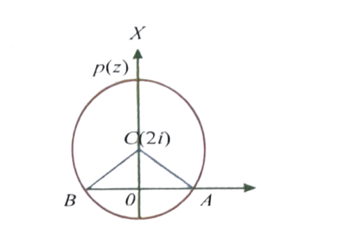





Clearly 

 

1. Let then 
2. Multiplicative inverse of Z is 
3. 



1. 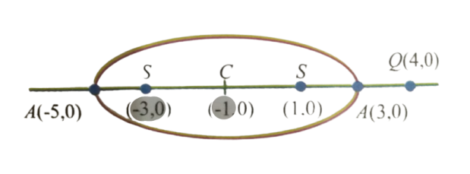



be a point on ellipse and



Min of PQ=1 and of PQ=9

1. 



1. Put a=1 and find square root
2. Using square root formula

 and 

1. lies in 







1. New position =
2. 









1. Let 







1. 
2. 





1. 



=

1. 
2. The given points from square
3. , , 

Now

 Triangle is equilateral

1. Locus of z is a circle having (-1,0) and (1,0) as its ends of diameter
2. Put 

Then 

1. 

,  lies on square

1. 



1. Let ,then





1. Real part of and imaginary part >0
2. ( by coni’s theorem)



1. 
2. Put n=1 and verify
3. ,
4. 
5. 





1. [sum of roots -1]



1. Use 



 

1.  ; 
2. 4th roots of unity are 

Product if 4th roots of unity =-1

1. 





1. are vertices of an equilateral triangle



***MATHS B***

1.  ,

,

 ; 

1. X-co ordinates of foci are equal



, centre is midpoint of 

1. , vertices are  and directrices are given by 

Thus a=6,  and so  which gives 

1. Normal at  ; passes through









1. Given eq.of the hyperbola



Req.eq.of the hyperbola



1. H+C=2A
2. As vertices are ,  

, so the required equation of the hyperbola is  and the foci are 

1. 
2.  
3. 
4. 
5. 
6. 

, directrix is ,

Latus rectum passing through ,

1. Y-coordinates of centre, vertex , focus are equal , 
2. lies on the directrix
3. 
4. and 
5. The product of the perpendiculars from the foci on any tangent to the hyperbola is 
6. Slope of tangent 

Slope of normal 



1. , and 
2. Equation of the chord is 
3. Equation of the chord , as its mid point is 

Slope of the chord =2

1. and 
2. Equation of the tangent at is .

Equation of auxiliary circle 

1. 
2. S. d between y=x and hyperbola  is the distance between line y=x and tangent
3. Equation of tangent to hyperbola is  It touches parabola also Equation of tangent to parabola.

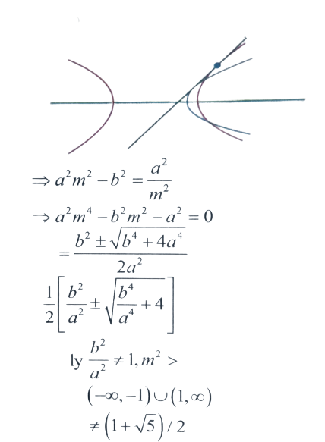

1. Slope of chord joining P and Q =slope of normal at P and 







From (1) 



1. Reflection of With respect to

is 

1. Locus of Q is 
2. Take

And  and proceed.

1. 



Sum of the roots

1. Equation of hyperbola will

Be 

1. Y-coordinate of foci are zero





1. 
2.  

 





1. Solve x=9 and equation of tangent at point of contact is 
2. 
3. 
4. 

**PHYSICS**

1. 
2. Conceptual
3. 
4. Conceptual
5. 
6. Conceptual
7. 
8. 
9. 
10. Conceptual
11. 
12. 
13. 
14. 
15. in the given point region slope of the graph
16. Work done by electric field is equal to change in kinetic energy
17. Conceptual
18. Conceptual
19. 
20. 
21. Potential of sphere is equal to potential at the centre of sphere due to point charge
22. Force=electro static pressure x Area of hemisphere
23. Independent of area of cross section
24. 
25. 
26. 
27. 
28. Ohm’s law
29. 
30. 
31. ; 

Series; Parallel

1. Combination of resistors
2. Electric field at the centre is equal to electric field due to single charge
3.  



1. (3) K.E=FS
2. Potential difference
3. 
4. Current through any cross section remains same
5. =
6. Conceptual effective resistance by series and parallel combination

**CHEMISTRY**

1. 
2. Rosenmund’s Reduction
3. 

1. is Benzaldehyde. This reaction is called Gattermann Koch aldehyde synthesis
2. 
3. 



1. Without Hydrogen Aldehyde shows cannizaro reaction
2. X = Formaldehyde
3. Conceptual
4. Oxidation
5. reduces C=C, When phenyl group is present position
6. 
7. 
8. Addition of 
9. 
10. Present in red ants
11. Conceptual
12. 
13. 



1. TrifloroAceticacid> trichloroAceticacid> formic Acid> Acetic Acid



1. Absence of Hydrogen will not give  Reaction
2. 



1. 
2. 
3. Basic nature gaseous phase 
4. Schotten Baumann
5. Conceptual
6. Conceptual
7. Conceptual
8. 



1. Conceptual
2. Conceptual
3. Conceptual
4. Conceptual
5. Conceptual



**PAPER SETTER: HYD-CP:-**

**MATHS : MR.VENUGOPAL SIR : 8919967743, 8919967743**

**PHYSICS : MR. AMRUTHAMU SIR : 9573761674**

**CHEMISTRY : MR.RAJU SIR : 9908359327**